The Assistant Director,
Directorate of Skill Development,
Srinagar.

No: KGP/Estt/2026/530 Dated:25-06-2026

Subject: Submission of details of retired Skilled Technical Personnel for Central Workshop, Central University of Kashmir.

Sir,
Kindly refer to your letter No. DSDD-Poly/36/2026-05-7910518/975-1012 dated 24.06.2026 on the subject cited above. In this connection, the details of the retired skilled technical persons are given below:

S.No | Name | Contact Number | Email Address
1 | Tariq Abdulla Bhat | 7006695804 | tariqabdullah298@gmail.com
2 | Aftab Ahmad Nalband | 7006979722 | aftabnalband12345@gmail.com

Yours Faithfully
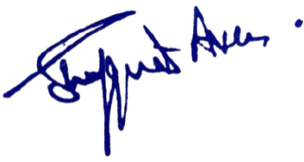

Dr. Shafquat Ara
Principal
Kashmir Government Polytechnic College
Srinagar

